Vending Machine Controller Simulator

NAME: Ganti Sai Kapil Akash
ROLL NO: 2620030182

1. Project Abstract
The Vending Machine Controller Simulator is a software-based simulation of a vending machine that automatically manages product selection, payment, item dispensing, and change calculation. The system is designed to demonstrate the working principles of a real vending machine controller without requiring physical hardware.
The simulator provides a user-friendly interface where users can view available products, select an item, insert virtual money, and receive the selected product if sufficient payment is made. It also calculates and returns the appropriate change. The system maintains product quantities and prevents the selection of unavailable items.
This project demonstrates concepts such as finite-state machines, conditional logic, inventory management, user interaction, and transaction processing. It can be used as an educational project for understanding how automated control systems operate.

2. Advantages
- Easy to use: Provides a simple interface for selecting products and making payments.
- Cost-effective: No physical vending machine hardware is required.
- Safe testing environment: Different transaction conditions can be tested without financial or hardware risks.
- Inventory management: Keeps track of the quantity of available products.
- Automatic change calculation: Calculates the remaining balance and change.
- Error handling: Can identify insufficient payment and unavailable products.
- Educational: Helps students understand controllers, state transitions, and automation.
- Easy to modify: New products, prices, and features can be added easily.

3. Implementation Details
- Display Products: Shows the available products, prices, and stock quantities.
- Select Product: Allows the user to choose a product using its product number.
- Check Availability: Checks whether the selected product is in stock.
- Enter Payment: Allows the user to enter the required amount.
- Verify Payment: Compares the amount entered with the product price.
- Dispense Product: Confirms the selected product for the user.
- Calculate Change: Calculates the extra amount to be returned to the user.
- Update Stock: Reduces the product quantity after a successful purchase.
- Display Transaction Result: Shows the product purchased, amount paid, and change returned.
4. Output Screenshots
Output 1 – Main Menu
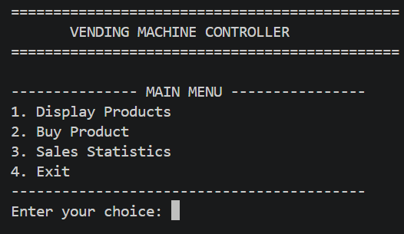

Output 2 – Display Products
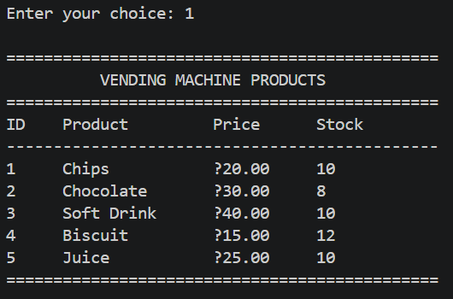
Output 3 – Successful Purchase
Example: User selects Chocolate and enters ₹50.
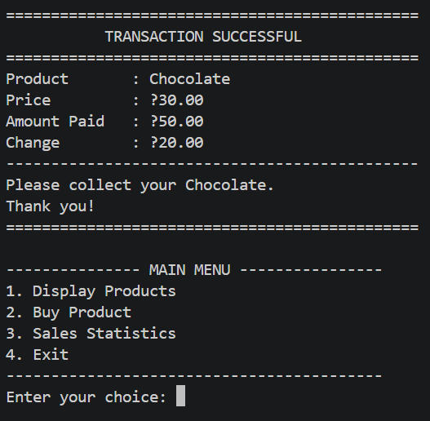

Output 4 – Insufficient Payment
Example: Chocolate costs ₹30 and the user initially enters ₹20.
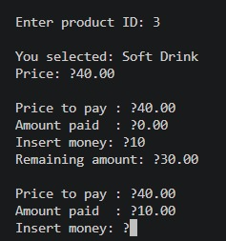
Then:
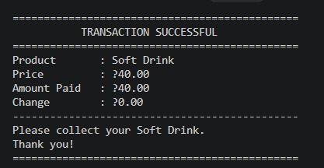

Output 5 – Invalid Payment
If the user enters 0 or a negative amount:
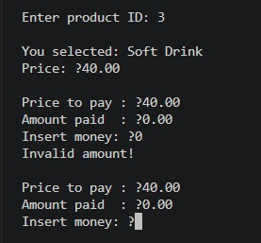
Output 6 – Invalid Product ID
If the user enters a product number that doesn't exist:
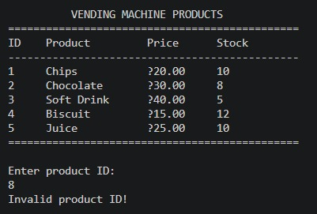

Output 7 – Out of Stock
If a product's stock becomes zero:
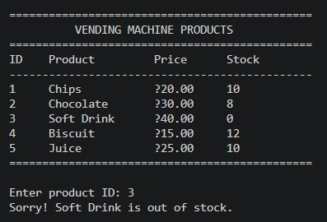

Output 8 – Sales Statistics
After some purchases:
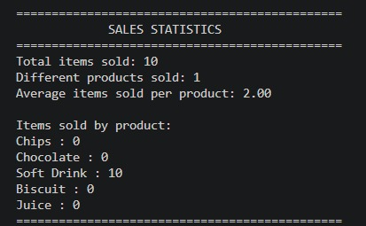

Output 9 – Exit
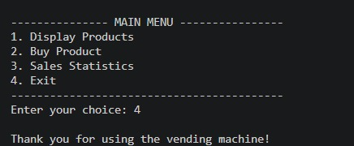

5. Conclusion

The Vending Machine Controller Simulator successfully demonstrates the basic operation of an automated vending machine through software. The system manages product selection, payment verification, inventory, product dispensing, and change calculation.

The project provides practical understanding of control logic, state-based operation, transaction processing, and user-interface design. Although it does not include physical vending-machine components, it provides a useful foundation for developing a real automated vending system.

6. Future Work
The project can be enhanced in several ways:
- Add real-time inventory monitoring.
- Integrate QR-code and digital payments.
- Add a database for storing products and transactions.
- Implement administrator login for managing inventory and prices.
- Add receipt generation.
- Connect the software to Arduino/Raspberry Pi hardware.
- Add physical motors and sensors for actual product dispensing.
- Implement remote monitoring of machine status.
- Add sales reports and transaction history.
- Improve the user interface with touchscreen-style controls.

